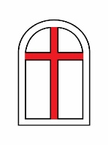
Little Harbor Chapel
Un-Denominational Chapel, Trust of Arthur Astor Carey

Memorial Brick Donation Form

Thank you for supporting our Little Harbor Chapel fundraiser. Please fill out the form below to purchase memorial brick for your $200.00 donation. Please write clearly on the form.
Please fill in all the information. *

- Your Name*

- Permanent Mailing Address (Address, city, state, zip code) *

- Your Email Address *

- Your Phone Number (With area code) *

- Please enter below, by printing, the inscription that you would like on the brick *
(20 characters or less on each line, spaces included).

Line 1:

Line 2:

Line 3:

*Note: Please mail your donation check for $200.00 made out to: Little Harbor Chapel
Please mail checks to: Little Harbor Chapel
C/O Managing Trustee
46 Autumn Ln
East Kingston, NH 03827

